

**Helping People Improve their Lives**

It’s Fun, Informative & **FREE**

*Are you on a Tight Budget?

*Has your Income Dropped?

*Are you running Out of Food?

*Would you like to learn how to Live on Less?

*Do you know how to Eat Healthy On a Budget?

If you answer YES to any of these questions the Eat Smart New York Program might be just what you need!

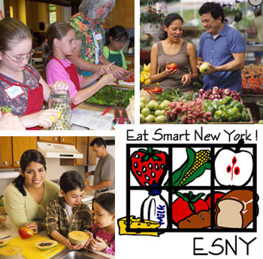

|  |
| --- |
| We can provide 8-12, 60-90 minute sessions customized to your individual needs with an EAT SMART NEW YORK Community Educator.  Provided FREE to anyone in Southern Erie or Cattaraugus County that qualifies. To find out if you qualify and more about EAT SMART NEW YORK call:  Cornell University Cooperative Extension  Serving  Southern Erie, Allegany and Cattaraugus Counties  (716) 699-2377 ext. 111 or 122 |
|  |