OneNote Tip Sheet for Families: 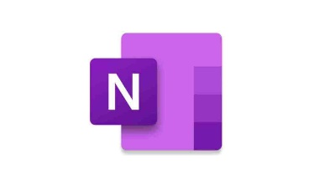

During remote learning, student’s work will be loaded on an app called OneNote. OneNote allows students to have “notebooks” for each of their classes, and it allows teachers to assign and receive work from students automatically. Internet access is not required for students to complete work that has been preloaded to OneNote by their teacher. Below are some answers to frequently asked questions.

How do I find my student’s work?

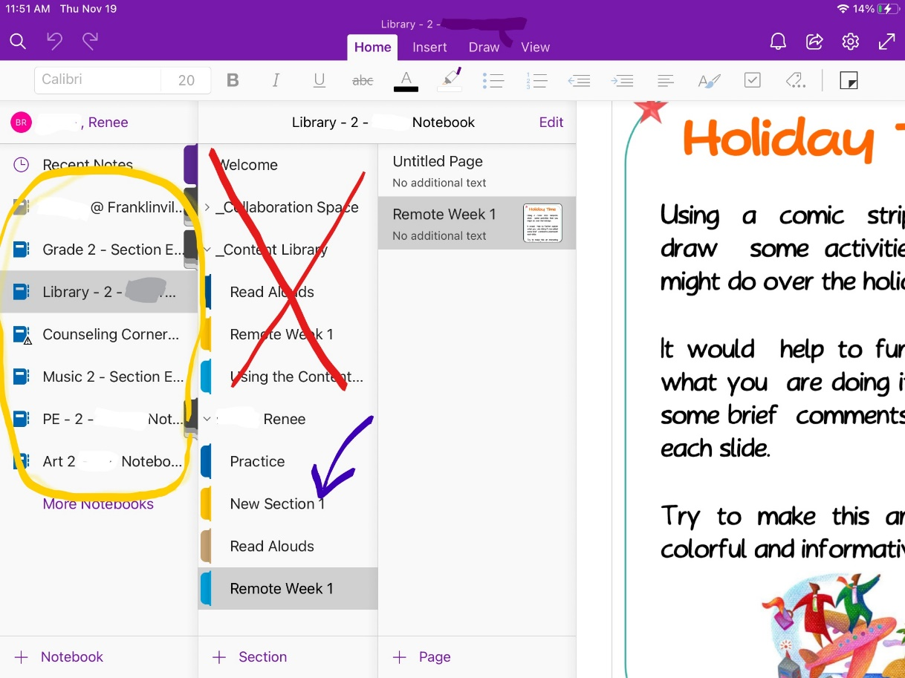

When a student opens OneNote, all of their class notebooks are displayed on the left (circled in yellow). If these are not visible when OneNote first opens, you may have to hit the back button until you can view all notebooks. Students should have a notebook for their classroom teacher, as well as PE, Art, Music, and Library. In a remote situation, students will have assignments in all 6 class notebooks. To navigate between notebooks, just select the notebook you would like to view on the left. Then in the 2nd column, find the student’s name and folders of work underneath (blue arrow). Choose the assignment and complete on the right.

How does my student complete the work?

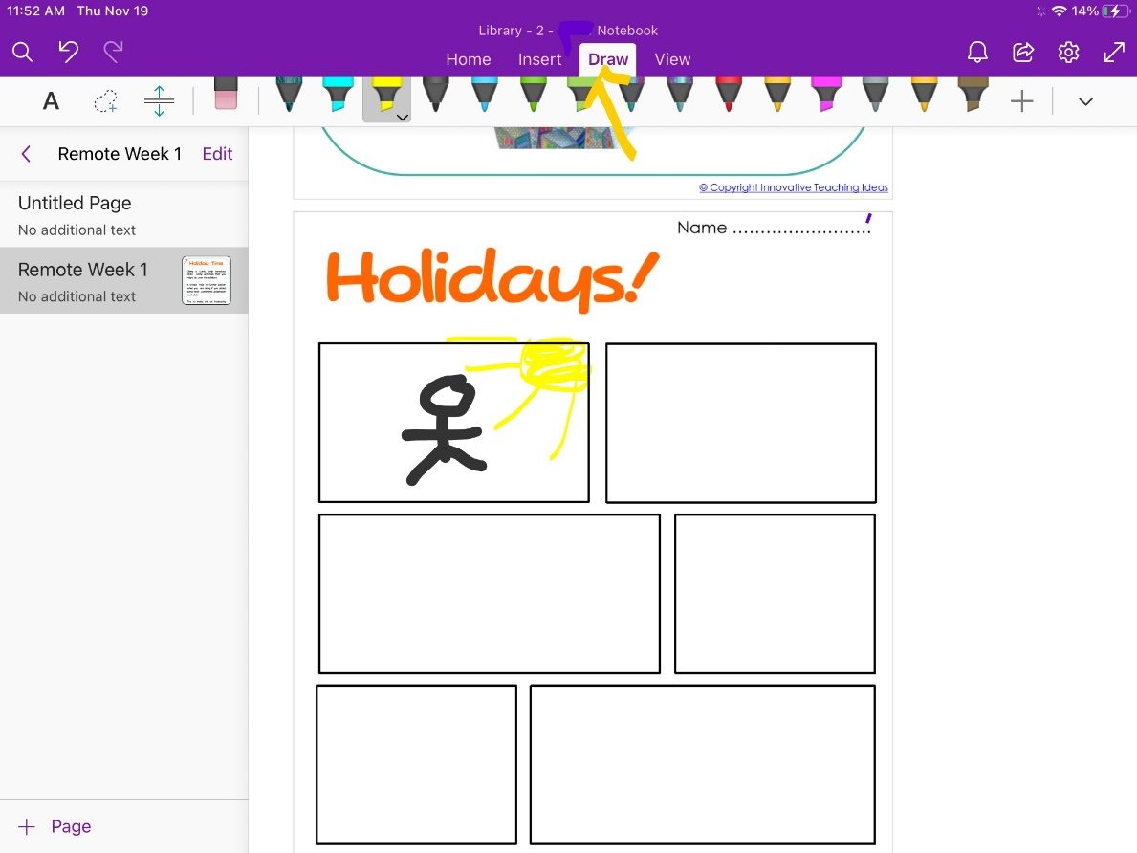

If your student needs to draw or write using OneNote, choose the “draw” option on the top purple bar. There are a variety of pens as well as an eraser. Student can use their finger or stylus.

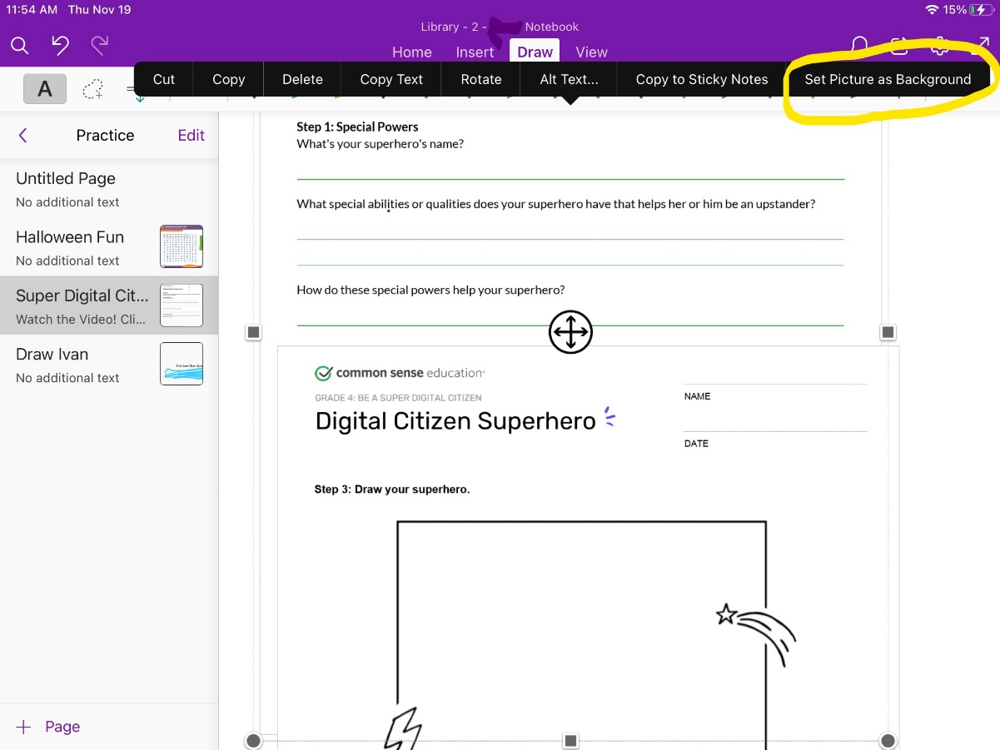

Once the assignment is completed, it should save automatically. It will sync to the teacher’s account as soon as the device is connected to the Internet.

If your student needs to type on a document in OneNote, touch the document to select it and then choose “set picture as background.” Once you do that, the student can type anywhere he/she selects.